Adam Zucker
Reload Switch
ECEN4013
Guidelines for Research Datasheet

I Provide a block diagram, flowchart, and/or public function headers of your block(s) for the system you will prototype in the next stage of the project.
- Label all inputs and outputs consistently.
- If required estimated external memory requirements
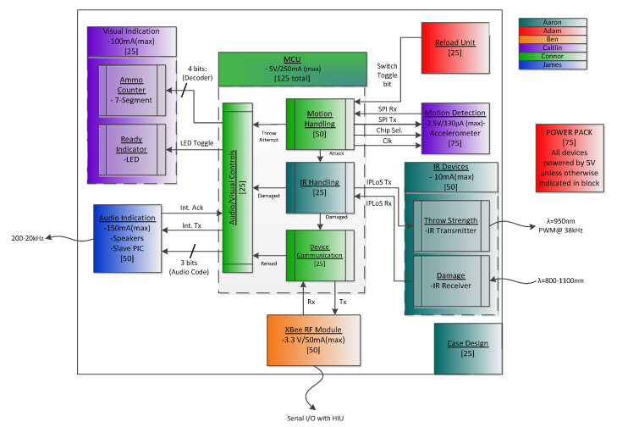
Figure 1 – Team Endeavor’s Level 1 block diagram

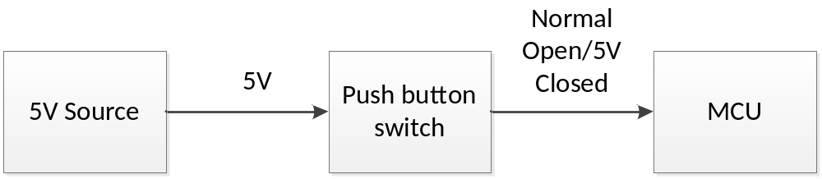
Figure 2 – Level 1 block diagram of reload unit

Tactile push button switch (Manufacturer part # 1437565-4)
- Switch will need to be pressed while reload process occurs.
- Releasing the switch ends the reload process.
- Switch will be located in an easily accessible spot on the shuriken.
- When switch remains open, power will not be consumed by push button switch or MCU.
- When switch is pressed in, a 5V signal will be sent to MCU indicating that the reload process is initiated.
- All process will be handled by MCU.
- Actuation force of 160G is the same force needed to press a key on a keyboard.
- Approximate price of push button switch is $.65
- With only a 4mm required clearance on top of the PCB, this switch will still allow shuriken to remain thin.

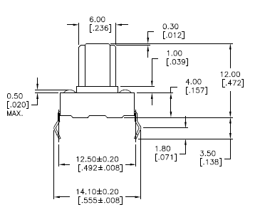

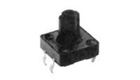

Sizes are mm [inches]
*Image taken from http://www.mouser.com/Search/include/LargeProductImage.aspx?path=tycoelectronics/lrg/pr1q89d15a.jpg
Miniature push button switch (Manufacturer part # 3-1437565-0)
This switch was a close alternative. It is surface amount as well, but the downside to this switch was finding a switch with a large enough actuator that is still being manufactured and stored in stock. The switch below only has an actuator length of .71mm which is very small and may be tough to actuate.

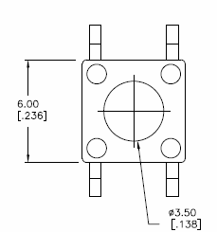
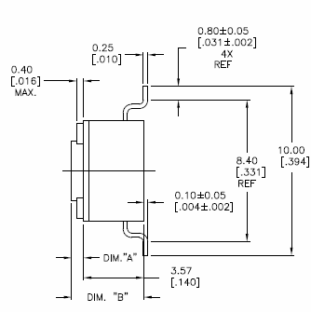

All sizes are mm [in] A = .71[.028] B = 4.29[.169]

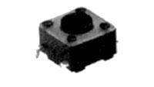

*Image taken from
http://www.mouser.com/Search/include/LargeProductImage.aspx?path=tycoelectronics/lrg/pr1q89d11a.jpg
II Alternative Approaches
Provide block diagrams, flowcharts, and/or public function headers of the alternative approaches you considered and rejected. Describe in a short paragraph why you feel these are not viable options.

Small momentary switch
The disadvantage to this switch is large and awkward size. This switch sits 11mm above the case, and 15mm into the case. The price of this switch is approximately $2.50, being the second most expensive switch of the choices.

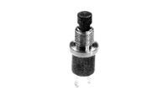

*Image taken from http://www.mouser.com/Search/include/LargeProductImage.aspx?path=tycoelectronics/lrg/pr1q89d41d.jpg

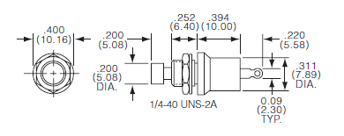
Sizes are inch (mm)
Toggle switch
The disadvantage to using the toggle switch is the ease of flipping the switch. The reload process will be a quick action and time cannot be used by trying to flip switch on and off. Toggle switches are also difficult to use with one hand. Another disadvantage of the toggle switch is the size. The toggle switch sits more than 12mm into the board, and has an additional 18mm out of the board. The price of the switch is approximately $3.30, being the most expensive of the choices.
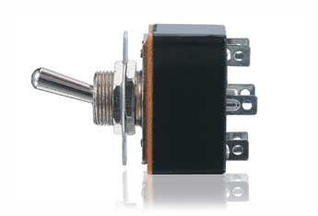
*Image taken from http://www.radioshack.com/product/index.jsp?productId=2062518

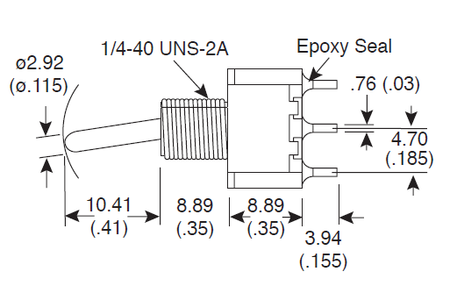
Sizes are mm (inches)
III Data Sources
In the table below list the sources of information you used in your research. These may include websites, datasheets, books, prior code, etc. Indicate which sources you will be using in your prototype. Please bring a copy of all the data sources you found useful

Type of datasource | Title, URL, etc. | Using in Prototype?
Datasheet | http://www.mouser.com/catalog/specsheets/TE_MSP103_PB.pdf | No
Website | http://www.radioshack.com/product/index.jsp?productId=2062518 | No
Datasheet | http://www.te.com/commerce/DocumentDelivery/DDEController?Action=showdoc&DocId=Customer+Drawing%7F2-1437565-7%7FU1%7Fpdf%7FEnglish%7FENG_CD_2-1437565-7_U1.pdf%7F2-1437565-7 | No
Website | http://www.mouser.com/ProductDetail/TE-Connectivity-Alcoswitch/3-1437565-0/?qs=sGAEpiMZZMvxtGF7dlGNpmdDR%2fLbgCKmhimT4XxJ6LQ%3d | No
Datasheet | http://www.mouser.com/catalog/specsheets/MS-100769.pdf | No
Datasheet | http://www.mouser.com/ProductDetail/TE-Connectivity-Alcoswitch/FSM102/?qs=sGAEpiMZZMuHTYi1bHPYEJtTpe%252bKl9MO | Yes

IV Simulation
Provide a simulation if possible or, if this is not possible, a graph or sketch of the expected inputs and outputs of your system. These should be correctly labeled and as quantitative as possible.

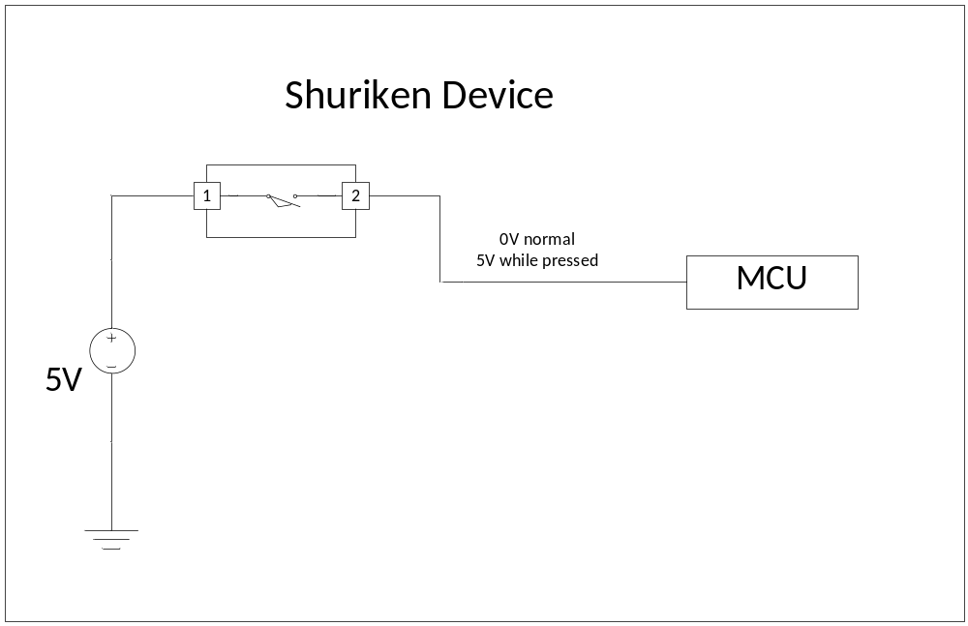
Figure 3 - Power flow of reload switch

V Discussion
Be prepared for an in-depth discussion of the results of your research with the instructor and/or TA’s.

Data taken from http://www.ikey.com/wb-86.html

